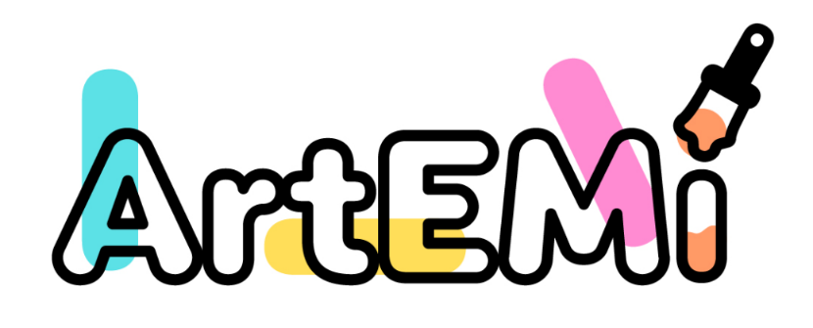

ARTEMI – Art and Education for social inclusion of migrant women
Erasmus+ Cooperation partnerships in adult education 2022-1-IT02-KA220-ADU-000089426

- The project aimed to:
- Create tools for the empowerment of migrant women, through the combination of effective training methodologies such as art therapy, storytelling, psychological support practices and mutual aid.
- Promote among migrant women of different ages and origins, resilience, creativity, to overcome psychological distress and facilitate integration into host societies, through activities aimed at increasing self-esteem and an attitude of self-entrepreneurship.
- -Involve a large number of organizations at local/national/European level in addressing the problems of migrant women.
In terms of tangible results, the project has produced:
• PR1 - ARTEMI TOOLKIT – This is a guide tool for educational activities based on art therapy for social inclusion through artistic-craft approaches, autobiographical narration techniques and digital storytelling to support migrant women in their projects for emancipation. The Toolkit contains:
- a section dedicated to the description of the methodological approaches used in the project;
- a section containing 21 workshops resulting from the experimental activities carried out.

• PR2 – ARTEMI OCCUPABILITY GUIDELINES - Guidelines for the employability of migrant women with activities – based on an art therapy approach – aimed at bringing out personal skills and abilities, improving transversal and digital skills, starting self-entrepreneurship projects, guiding them towards study and professional training. The guidelines contain:
- an introductory part concerning the methodologies for the development of skills in the workplace based on art therapy, autobiographical narration and digital storytelling;
- a section containing 12 workshops resulting from the experimental activities carried out by the project, concerning the development of soft skills, specific professional skills and skills for self-entrepreneurship.

• PR3 - ARTEMI SUPPORT PRACTICES - A publication concerning the practices of psychological support for migrant women and peer support groups, through art therapy and Sand play therapy approaches.

The project has produced three additional results, namely:
- a book of memories and recipes resulting from the cooking workshop animated by the DUN association;
- three video tutorials on the practices created by the project;
- a short film resulting from the cinema workshop created by DUN.

Download the results on the Artemi website:
https://www.artemi-project.eu/results/

Project’s Website
https://www.artemi-project.eu/

Partners
- Associazione DUN - Onlus
- Associacao recreativa, cultural e social de Silveirinhos
- Storie di mondi possibili
- Mobilizing Expertise AB
- Dafni Kentro Epaggelmatikis Katartisis

Disclaimer

Funded by the European Union. Views and opinions expressed are however those of the author(s) only and do not necessarily reflect those of the European Union or the European Education and Culture Executive Agency (EACEA). Neither the European Union nor EACEA can be held responsible for them.

